Big Al in the Lab
Jaws

Time: 12 minutes
Group Size: 8-15 students
Grade Levels: 2nd – 3rd
Location: Sahm Marine Education Center (Octopus Side)

OVERVIEW OF ACTIVITY

BIG IDEA
- Students know stories sometimes give plants and animals attributes they do not really have.
- Plants and animals meet their needs in different ways.
- Adaptations in physical structure of behavior may improve an organism’s chance for survival.

Students will examine the jaws of actual fish with magnifying lenses to determine the diet of each fish by identifying the general type of teeth. How does the diet of the fish correlate with its jaw structure and teeth? Based on these observations, what does Big Al eat - what do his teeth look like? Should the little fish be afraid of Big Al?

PERFORMANCE OBJECTIVES

Students will be able to:
- Identify one cruncher, grinder, and attacker set of jaws.
- Identify the type of teeth they think Big Al has and give reasons why.
- Form a hypothesis on whether the little fish should be friends with Big Al.

CHALLENGE

Observe and identify teeth that are like Big Al’s. Determine if the small fish in the story be friends with Big Al.

MATERIALS
- Jaw bones in boxes
- Puffer fish, shark jaw, sheepshead jaw
- Magnifying lenses, small and large
- Photos of fish
- Diagrams of feeding types
- Big Al book or page showing Big Al’s teeth

ADVANCE PREPARATION

- Set out the jawbones, pictures from book, pictures of fish, and Jaw Type Sheet.
- Set out the examples of each feeding type that can be touched (pufferfish, shark jaw, sheepshead jaw in dish).
- Clean the magnifying lenses and distribute them among the jawbones.

TEACHING TIPS
- Organize the students to go around the table in one direction and encourage close observation of the jaws. Make sure younger students know how to use a magnifying lens.
- Remember, Big Al is an imaginary fish. Big Al looks similar to a Cabezon or a California Sculpin, so we can use either as our representation of Big Al. The students will use the picture of the teeth from the book to decide what Big Al eats. If you look at the book picture you could say they are blunt (cruncher teeth), or sharp (attacker teeth) since they tore through the net. The answer to the question, “Should the little fish be friends with Big Al?” depends on what the students think the teeth look like. Either answer is correct with a valid explanation.

PROCEDURE

Engage (2 minutes):
- “We are going to see if this book is fact or fiction. We are going to decide if in the real ocean the little fish should be friends with Big Al.” Show the students a picture of Big Al. “Look at that big mouth!” Hold up the pictures of real fish. “Are all their mouths the same? We can learn a lot about what an animal eats by looking at the shape and size of its mouth and teeth.” Hold up the diagrams of the three types of teeth. “What you will do is decide what type of teeth each of these jaws are: attacker, cruncher, or crusher. Then we will decide what type of teeth Big Al has.”

Explore (7 minutes):
- Have the students observe the jawbones and decide whether they are attacker, cruncher or grinder teeth.
- The students should then formulate a hypothesis for what the fish eats. Facilitate the students’ observations as they move around the table and find examples of the three types of teeth discussed: attacker, cruncher, and grinder.

Explain and Extend (2 minutes):
Have the students show examples of all three types of feeding strategies. We can learn a lot about what an animal eats and how it gets its food by looking at its shape and other features, like its teeth.

- Were the jaws all the same? (No)
- How are the jaws different from one another? (Cruncher jaws have blunt individual teeth, grinder jaws have hard plates with no individual teeth, and attacker jaws have sharp individual teeth.)
- Do they eat the same food? (No. Grinders eat animals such as snails and corals. Crunchers eat animals such as sea urchins and crabs, and attackers eat animals such as other fish.
- Look at the picture of Big Al in the book. What type of teeth do you think he has? (The answer will vary depending on how sharp the students think the teeth are. Blunt teeth would make Big Al a cruncher, and sharp teeth would make Big Al an attacker.)
- Should the smaller fish be afraid of Big Al in the real ocean? (Answers will vary depending on how sharp the students think the teeth are. If they chose cruncher, the fish would not be afraid because crunchers do not eat fish. If they chose attacker, the fish should be afraid because attackers eat other fish.)
- Big Al is a great story, but would this happen in the real ocean? (This book is a fictional story and would not happen in the real ocean.)

Evaluate (1 minute):
- What did you like about the jaws station? Why? (Answers will vary depending on students’ experience.)
- What did you dislike about the jaws station? Why? (Answers will vary depending on the students’ experience.)
- What was the most difficult part of the jaws station? (Answers will vary depending on students’ experience.)
- How did you overcome the difficulty? (Answers will vary depending on the students’ experience.)

RECOMMENDED ASSESSMENT STRATEGY
Observe the students as they go around the jaws table; make sure they know how to use the magnifying lenses and provide feedback as necessary. Use the discussion questions and the number and type of questions asked and answered to assess student knowledge. Were they able to tell you if the little fish should be friends with Big Al? Why or why not?

ACTIVITY RESOURCES
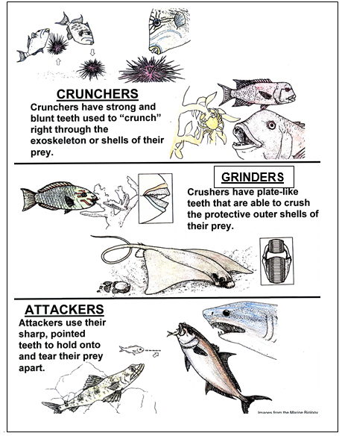
This is not a scientific classification scheme for jaw types. These three divisions are done for simplicity but are accurate feeding styles. Feeding in fish is not only related to tooth type but mouth shape and location. We do not get into this at this station. Fish do not chew their food since they need their mouth to let water in to breathe.
Attackers: We think of predators as having large sharp teeth, but large teeth are not always needed in fish. Fish predators may actively prey on other fish or wait in ambush. Water adds an element to feeding that land animals do not have. The density of water allows for ‘sucking in’ food. Fish have buccal cavities which allow water to pass over the gills. Ambush predators that use suction as part of their feeding strategy have a very large buccal cavity allowing for the quick opening of a large mouth which sucks in large amounts of water and inhales the prey with it. Because of this, some predatory fish do not need large teeth but have small, backward facing, sharp teeth which keep their prey from getting out of the mouth.

Crunchers: Pick and eat invertebrates that have exoskeletons or shells which aren’t too hard. They need sturdy teeth to crunch through these defenses.

Grinders: Grazers or grubbers that feed on very hard organisms. They eat things so hard that teeth would break. They have fused, plate-like teeth to grind up the hardest coral or large shell to get the food inside.

Other: Some fish do not rely on teeth at all to eat. For example, pipefish suck in plankton with their long snouts and anchovies filter feed using their gill rakers.

BACKGROUND INFO

VOCABULARY
Cruncher Jaws- Jaws with blunt, individual teeth.

Grinder Jaws- Jaws with hard plates and no individual teeth.

Attacker Jaws- Jaws with sharp, individual teeth.

Prey- An animal which serves as food for another animal.

Predator- An animal that hunts for its food.

